AVST LT Series Auto Backup through FTP

- Preparation
  - Requirements
    - desktop computer
    - internet connection
    - ‘Filezilla Server’ freeware software

- Downloading Filezilla Server
  - Goto http://download.eyemaxdvr.com
  - Type ‘storm’ for ID and ‘superdome’ for Password.
  - Choose ‘AVST LT Series’ and then ‘AutoBackup’
  - Download ‘Filezilla Server’
  - Install Filezilla server by double clicking the downloaded file.
    - You can click ‘next’ and ‘ok’ all the time during the installation and until you get the main screen of the program.
    - 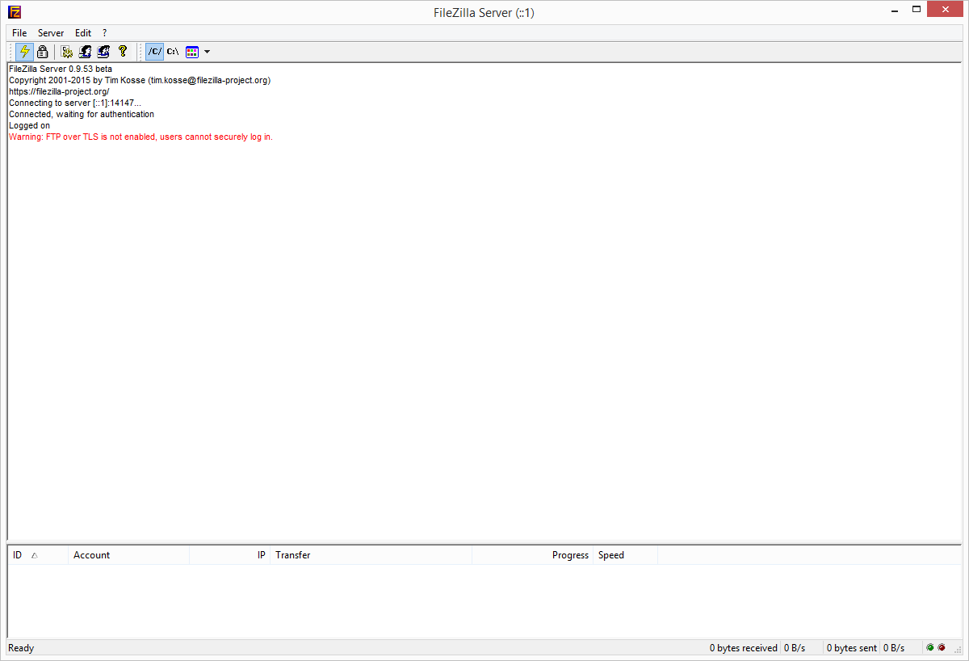

    - Click ‘User Icon’
    - On the left panel, click ‘Shared folders’ and then Click ‘Add’ in the ‘Users’ on right side of window.
    - Add user account(ID), you can create anywords, example, type ‘admin’ and then click ‘ok’
    - Now click ‘Add’ in the ‘Shared folders’ and choose ‘Documents’ the press ‘ok’
    - 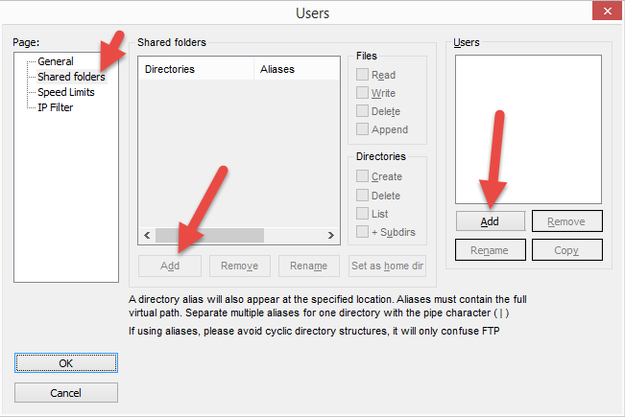
    - 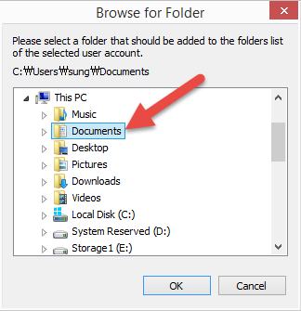
    - Go to ‘General’ tab and create password, let’s type ‘password’ for password.
    - Now you are all set, save all setting by clicking ‘OK’ on the bottom left of the setting window.
    - 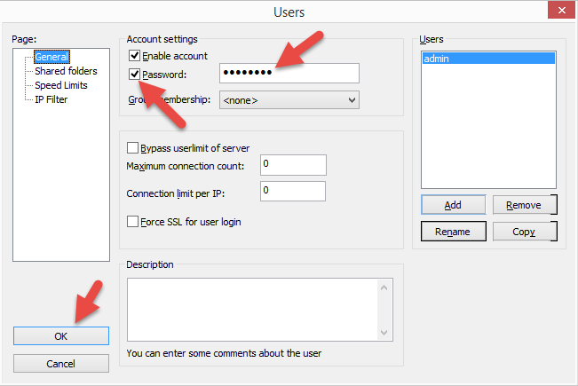
    - One last step is that you need to get the public IP address of the FTP server location, simply go to http://www.canyouseeme.org and it will display your public IP address. You can write it down for the setting later in the next DVR setting step.
    - 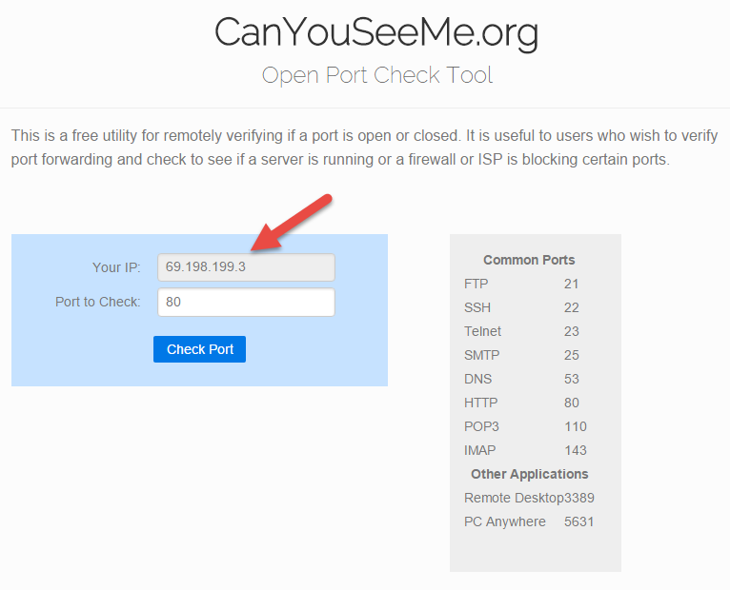
- Setting up DVR
  - Right click on ‘Live View’ and it will pop up menus.
  - Click Backup Icon
  - 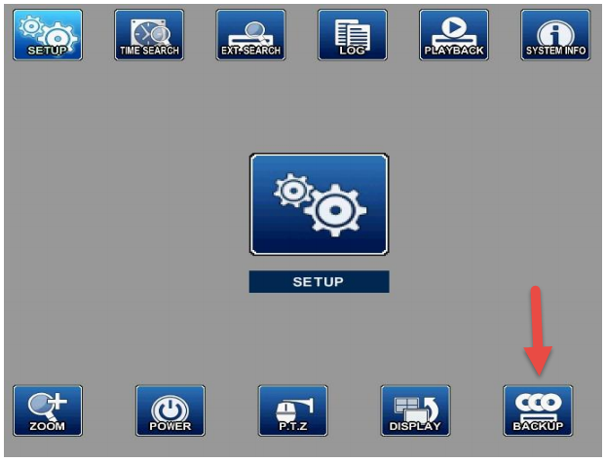
  - Select ‘Auto Backup’ tab on the top and then Select ‘FTP’ in the ‘Device’
  - 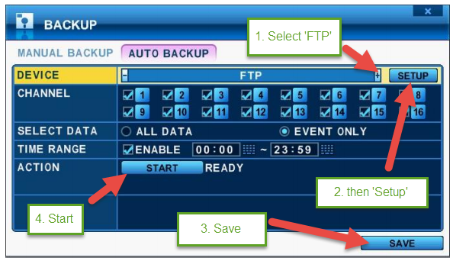
  - And then Click ‘Setup’
  - Insert the Public IP address that was from canyouseeme.org
  - Port 21, Authentication ‘ON’ and then type USER ID ‘admin’ and PASSWORD ‘password’ (these are the setting from FileZilla). Connection Type should be ‘Passive’
  - You can create the name of ‘Backup Path’ or it will given the random name(Mac Address of DVR). You can name it like “DVR Backup” this name will appear on your ‘My Document’ folder on your desktop computer.
  - 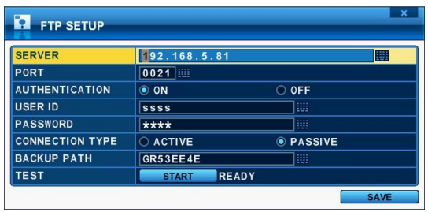
  - Click ‘Test’ ‘Start’ to test the connection. And then click ‘Save’
  - Now you are all set click ‘Save’ and then ‘Start’ in ‘Action’

- Convert the file and play.
  - Run ‘AviConverter’ (you can get it from http://download.eyemaxdvr.com -> AVST LT SERIEST/SOFTWARE)
  - 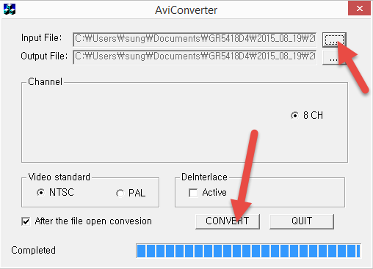
  - 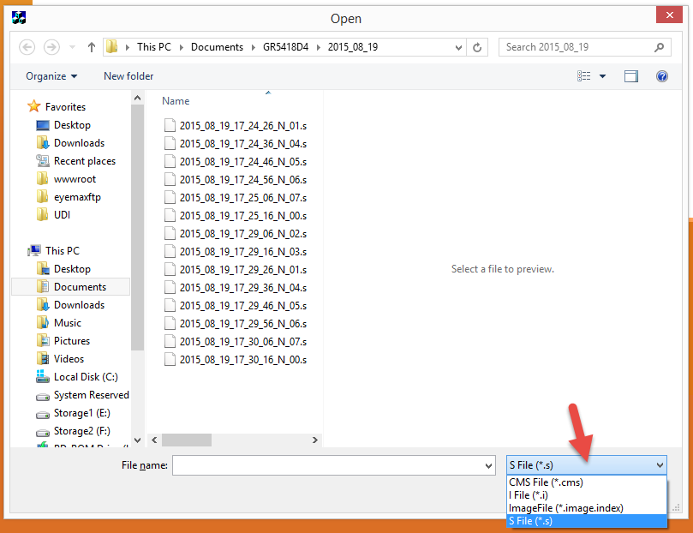
  - Browse ‘Input File’ and then Choose ‘.s’ extension
  - go to ‘Documents’ folder on your desktop computer. The folder will be either DVR’s Mac address or ‘DVR Backup’ as we set it in the setup before.
  - Folders are generated automatically by the recording date. Choose the date you want to play.
  - The file format will be Year_Month_Day_Hour_Minute_Second_Channel Number.s
  - Choose the file and then ‘Convert’ it.
  - If your media player doesn’t play it or laggy. Download the codec pack in the same folder at http://download.eyemaxdvr.com

