How to use DFS2AVI Converter
Overview:
- DFSI is to convert DFS data file to AVI file.
- Working with HR04, HR09, HR16 only.
- Working on the Microsoft Windows.

How to use:
- Execute dfs2avi.exe
- Click “Open” button and locate data file in the dfs folder
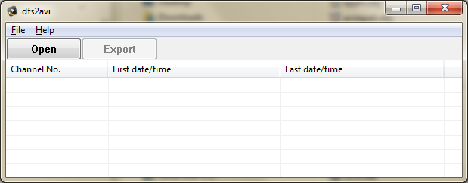
- Select Channel and click “Export“ button. To convert.
- Specify destination folder to create AVI file.
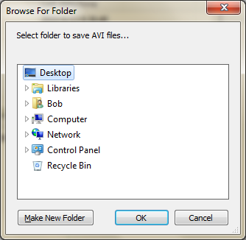
- Recognize date and time by AVI file name.

- To playback AVI file, ffdshow codec is necessary.
Ffdshow download link: http://www.free-codecs.com/ffdshow_download.htm

