**ITC237-PW6M-IR**

**ITC237-PW6M-L**

**Construction Documents**

**-------------Only for north America**

Models

|  |  |  |  |
| --- | --- | --- | --- |
| **Model** | **Description** | **Focal Length** | **Pixel** |
| DHI-ITC237-PW6M-LZF1050 | Long Range Access  ANPR Camera | 10 mm–50 mm | 2 MP |
| DHI-ITC237-PW6M-IRLZF1050 |
| DHI-ITC237-PW6M-LZF1050-B |
| DHI-ITC237-PW6M-IRLZF1050-B |

1. **Installation Scheme**
2. **Pole distance and equipment installation**
   1. Mounting height and the best distance to capture

|  |  |  |  |  |
| --- | --- | --- | --- | --- |
| Installation Method | Camera Height | Lane Width | Snapshot Distance(min，max) | Best distance to capture |
| ITC237-PW6M | 3m | 3.5m | 7~14m | 9~12m |
| 4m | 3.5m~7m | 8~16m | 14~16m |
| 5m | 3.5m~7m | 9~18m | 14~18m |
| 6m | 3.5m~7m | 10~30m | 25m |

* 1. In the case of formal installation, the relationship between the installation height H and the capture distance X is X≥1.7H. For example, in the case of 6m height in the standard scheme, the minimum capture distance is 10.2m.

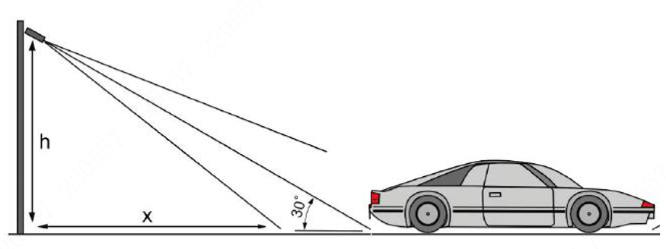

➢ The host is installed in the center of the scene；

➢ The pole is 6 meters high；

➢ Figure 1.1-1 takes 2 lanes as an example to show the formal installation mode of the system

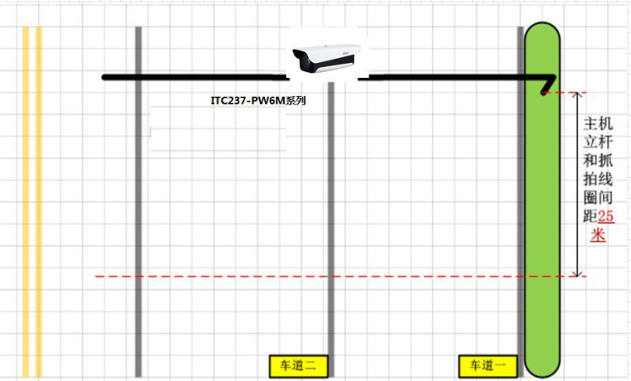

Figure 1.1-1 Formal installation scheme diagram

* 1. In the case of side installation, the relationship between the widest distance h between the camera and the lane and the capture distance x is x≥1.7h.Refer to the corresponding formal data for installation.



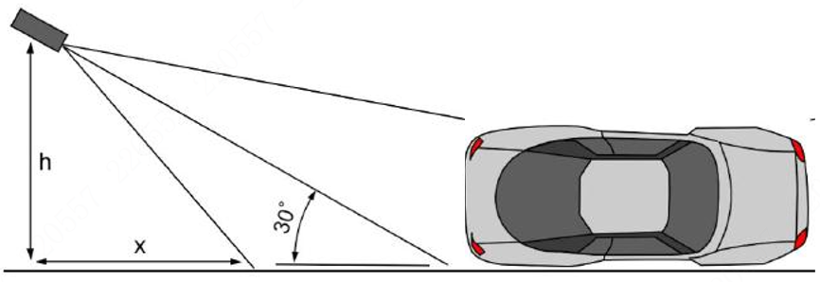

➢ The host is installed on the right side of the scene；

➢ The pole is 6 meters high；

➢ Figure 1.1-2 takes 2 lanes as an example to show the system's test and installation mode

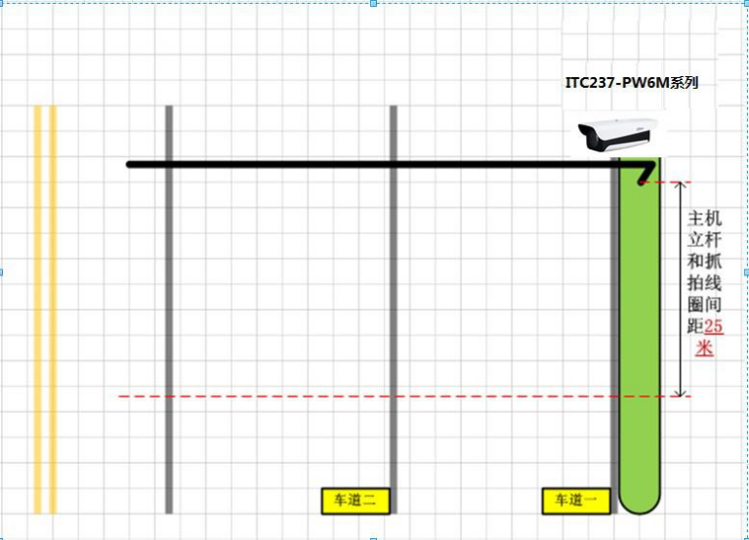

Figure 1.1-2 Side mounting scheme drawing

* 1. License plate pixel point is required to be 140-160 optimal

1. **Software**
   1. **Web Parameter Configuration**
      1. General Settings

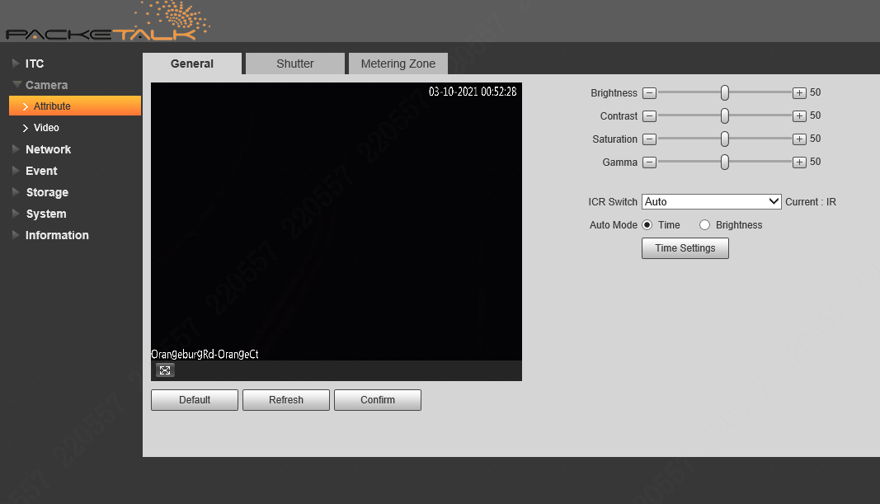

* + 1. Set the shutter

Check the camera web page to debug the shutter and gain parameters, and adjust appropriately according to the situation.(Default parameters are recommended)

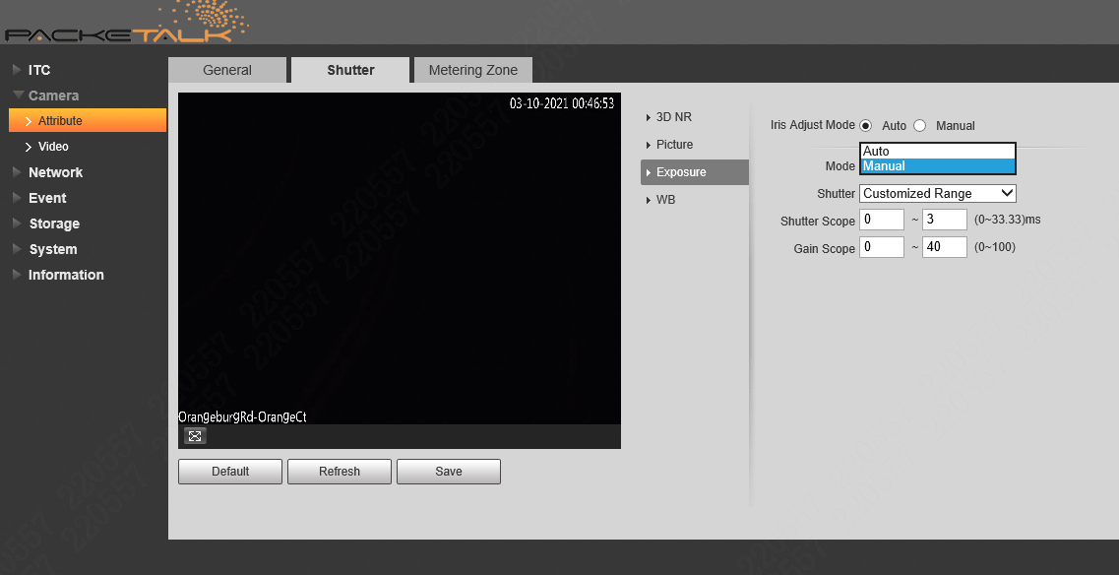

**Use Manual, not Auto**

**Different scenes have to be adjusted because of different lighting**

For example, if the shutter and gain are too high, the license plate will be overexposed, as shown in the figure below.

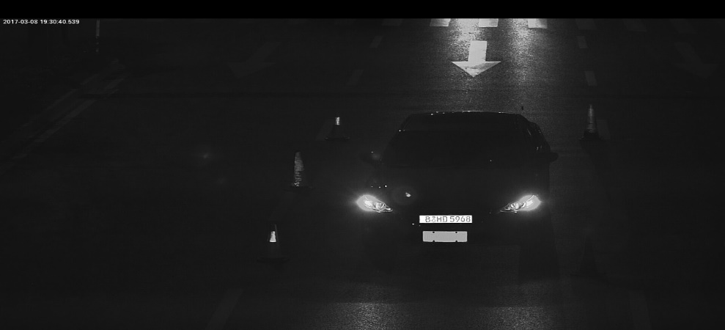

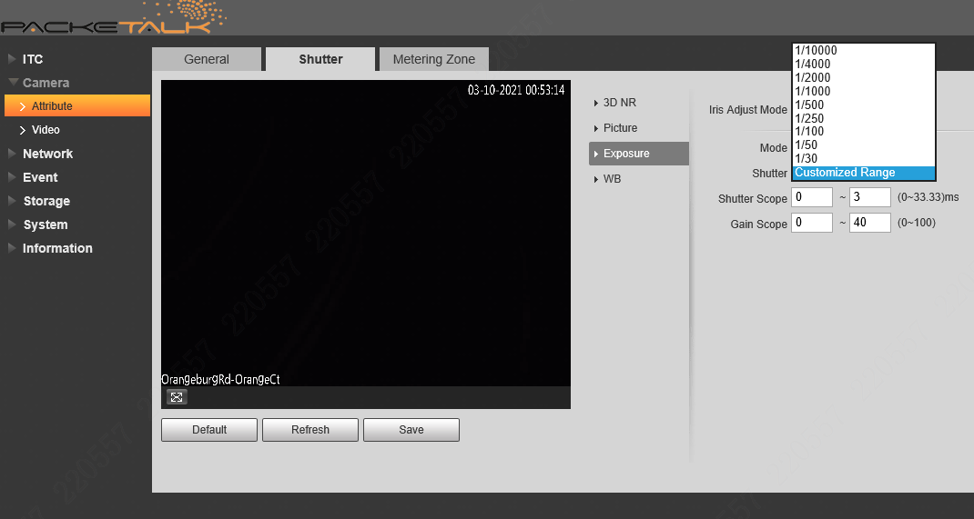

**Default parameters are used and no adjustments are required.**

* + 1. Metering zone(Adjust the image effect, not recommended)

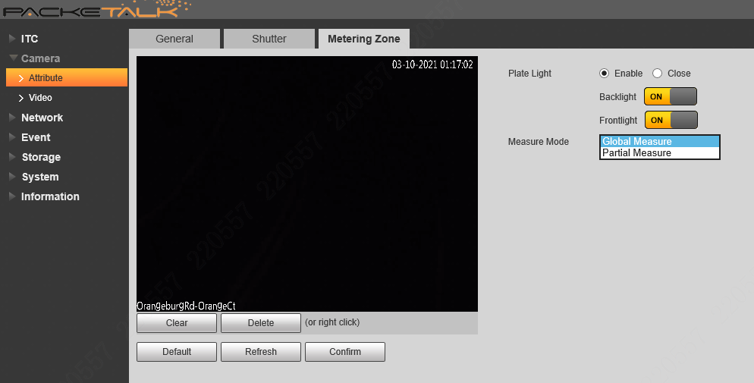

**Default parameters are used and no adjustments are required.**

* 1. **Configure for Image Issues：**
     1. Overexposure during the day

Because the sun is hitting the license plate, it is directly reflected off the camera lens, causing the image to be overexposed.There are several general strategies:

1. Try to avoid east-west direction in installation;
2. Do not install the camera in the direction where the sun is just reflecting back, as shown in the picture below, it is recommended to install the camera on the B side of the road, not the A side;

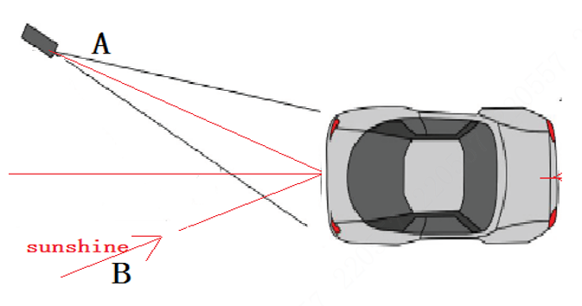

1. Use automatic aperture lens；

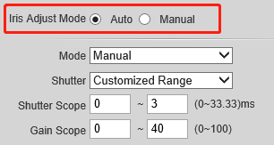

1. Open WDR；

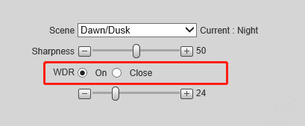

* + 1. Overexposure at night

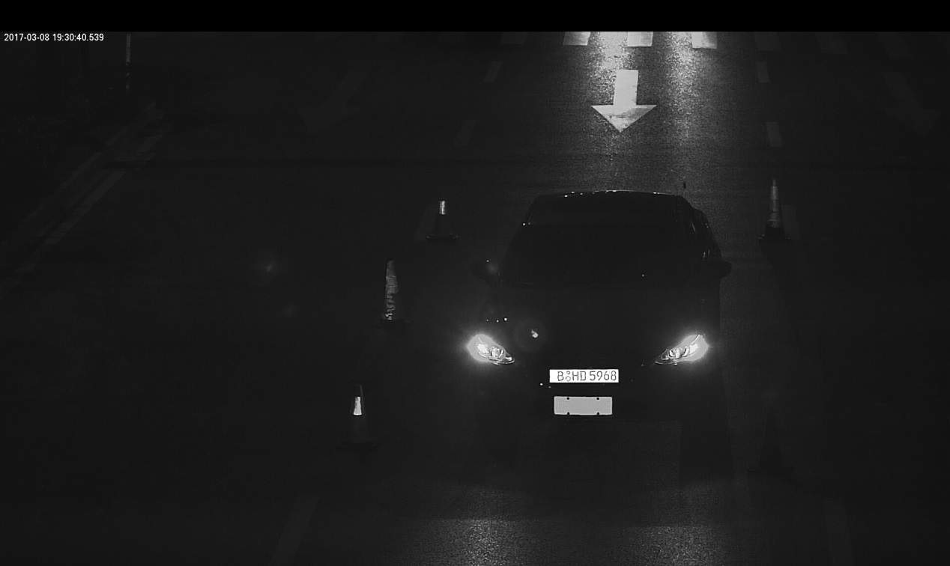

**Overexposed Picture**

There are about three kinds of overexposure in the evening:

1. The influence of the vehicle headlights, resulting in the inability to see the license plate;

Solutions:

1. Open WDR；



1. Turn on the supplementary light of the camera;

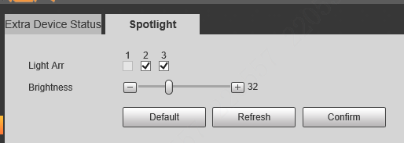

1. Other vehicles have their license plates irradiated, resulting in overexposure；

Solutions:

1. Avoid headlight reflection angles;
2. Try to select parallel lanes for installation;
3. The camera's own light is too bright or the Angle is affected；
4. Reduce the brightness level of the camera lamp itself；

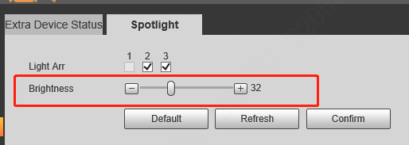

1. Reduce the number of lights on；

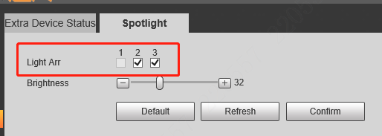

1. Decrease the shutter and gain parameter values appropriately (generally, it is recommended to use the default value, and increase the value is easy to drag);

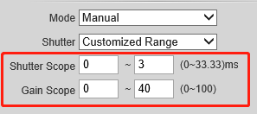

1. The picture is dark in the daytime;

The possible reason is that the backlight causes the license plate to be dark under the shadow of the car body, and the car body and other scenes are bright.

Solutions:

1. Turn on camera width motion or backlight compensation；



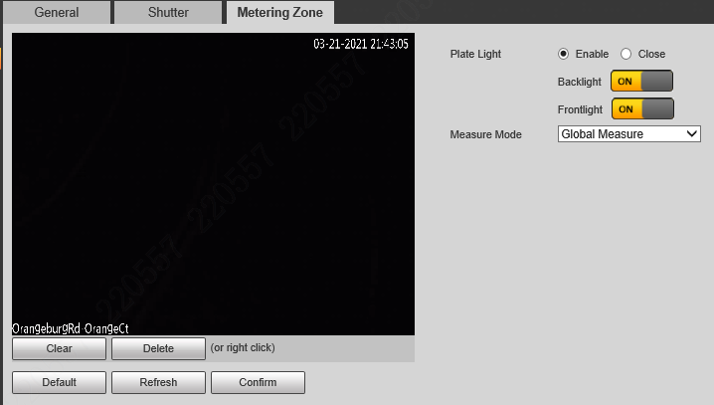

1. To much noise in the picture;

Generally, the gain setting is too large, or the image is too dark and the brightness is forced to increase.

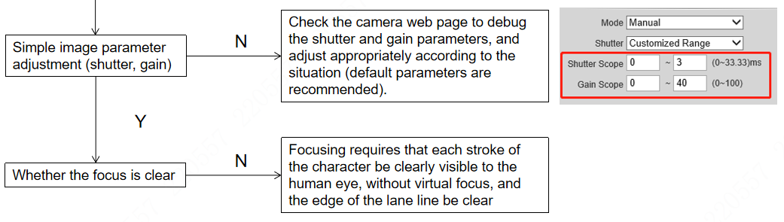

* 1. **For the problems of license plate recognition, not snapping, and low recognition rate:**
     1. Flow chart of problem location and solution

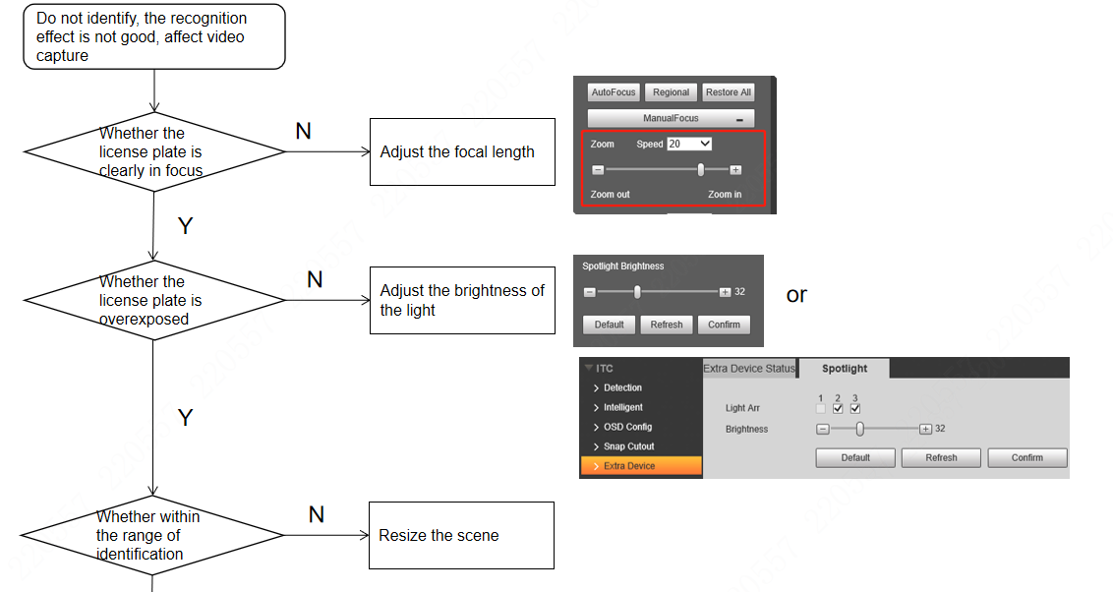

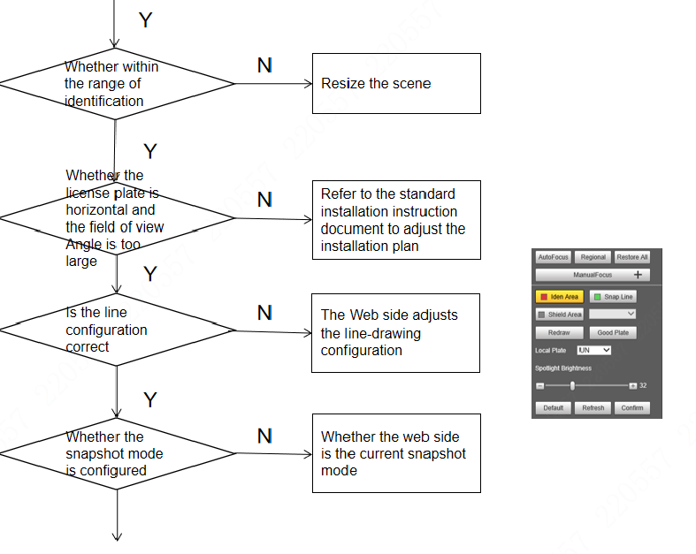

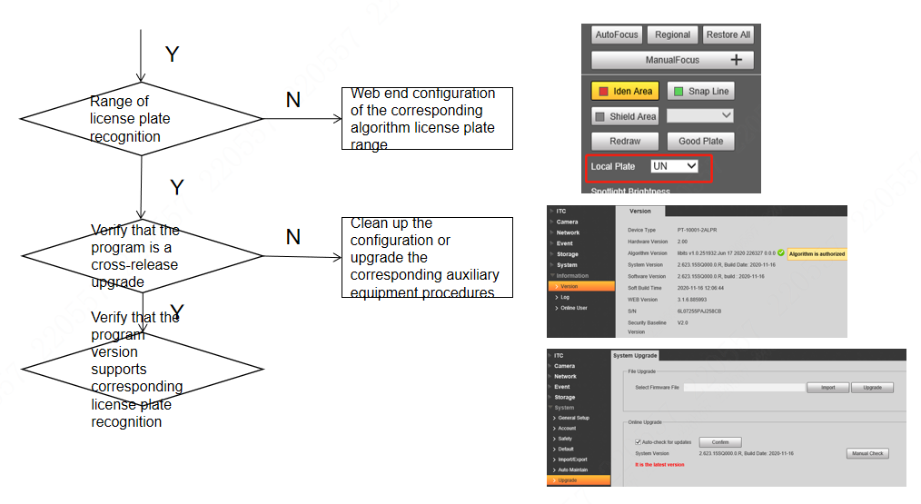

* 1. **Quick Configuration**

Click the **Guide** tab, and then you can start configuring the work mode of the Camera.

1. Conformation

Confirm information of **Software Version**, and then click **OK**.

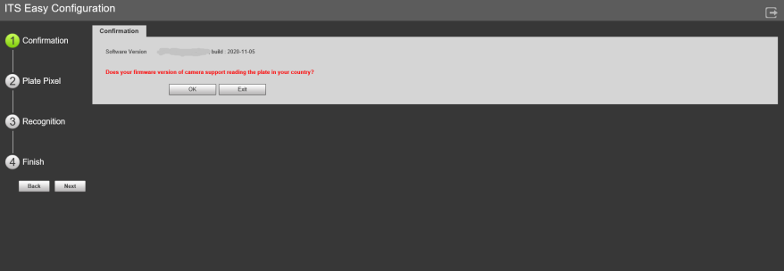

1. Plate Pixel

You can check whether the video image is properly zoomed and focused by checking the plate pixel.

1) Drag zoom and focus bar to adjust the video image properly.

2) When the vehicle plate comes into the green line area, click **Snapshot** to take a snapshot of the plate.

3) Zoom in the picture selected by the plate pixel box. It can realize 2x or 4x zoom rate.

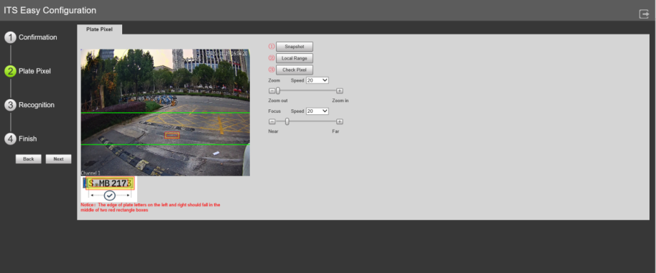

1. Recognition

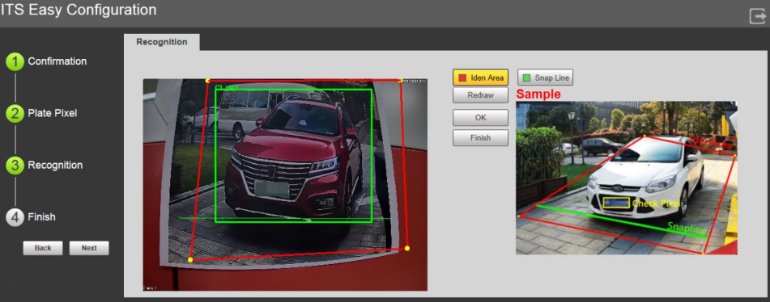

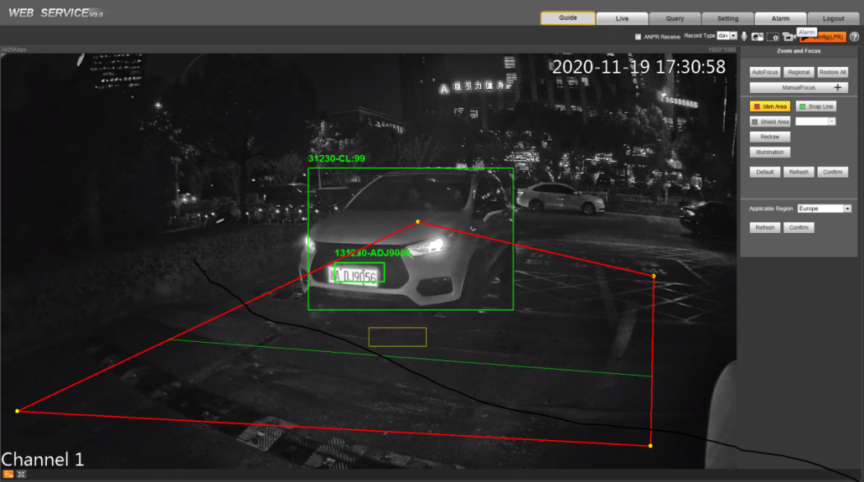

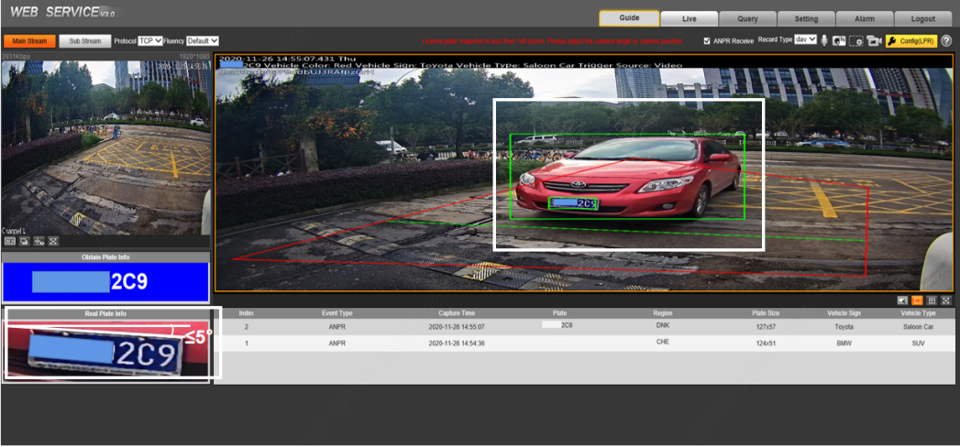

Canonical Snapshot Example

1. Make sure the vehicle is within the red identification area line;
2. The green snap line is about 1/3 of the road;
3. Angle between the bottom of the license plate and the screen ≤5°;
4. The license plate has more than 140 pixels.

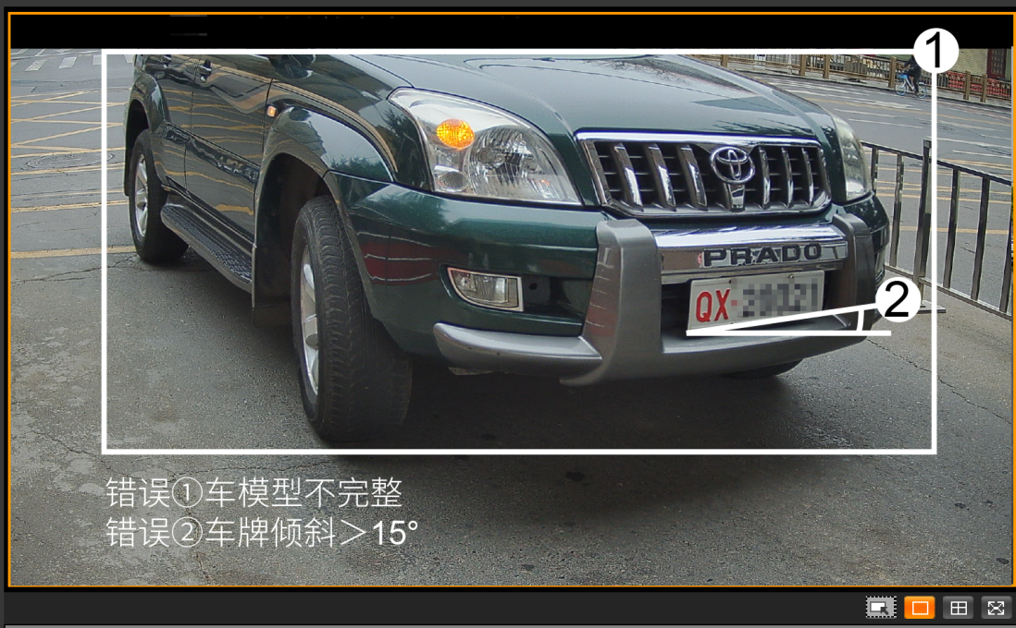

Nonstandard Example

1. The vehicle model is incomplete;
2. License plate tilt≥15°
3. **Setup> Camera > Attribute**

4.1 General

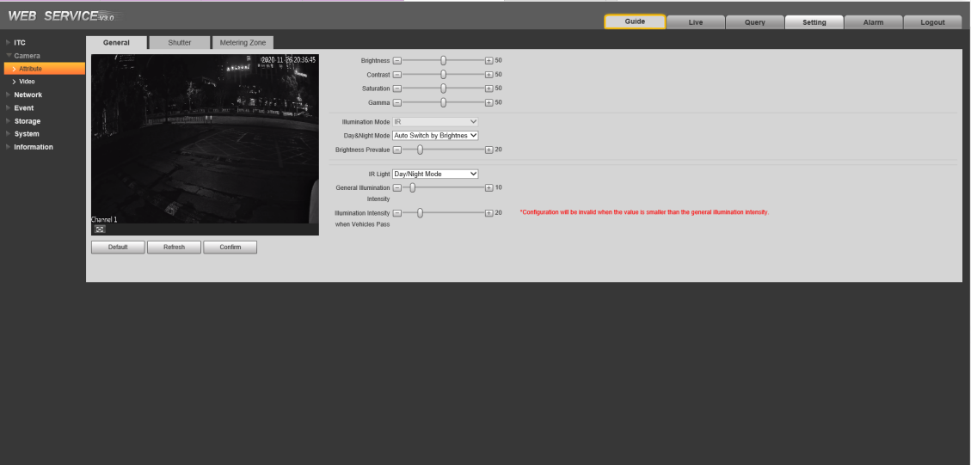

1. Brightness：The recommended value is from 40 to 60. The bigger the value is, the brighter the image becomes.
2. Contrast：The bigger the value is, the more obvious the contrast between the bright area and dark area will become.
3. Saturation：The bigger the value is, the more flamboyant the image becomes.
4. Shutter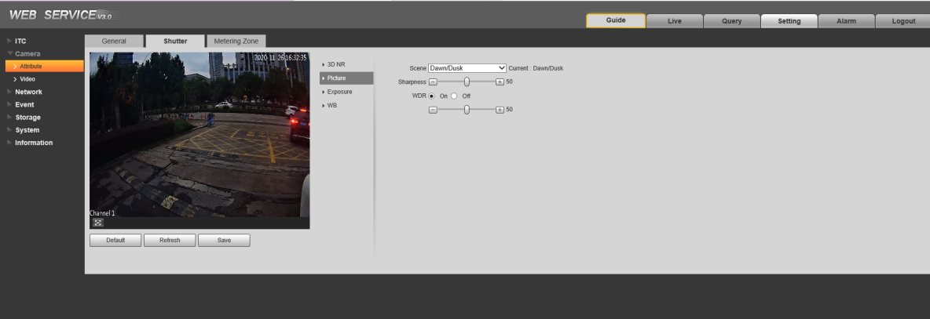
5. Select the way of adjusting exposure mode. You can select from **Manual** and

**Auto**.

1. You need to set shutter when Manual is set as Mode.You can select the shutter value, or select Customized Range, and then set the shutter range.
2. You need to set shutter when Customized Range is set as Shutter.  
   Set the time range of shutter.
3. You need to set gain scope when **Manual** is set as **Mode**. Set the value range of gain. The gain is no greater than 50.